- How can the problem of back gate coupling and charge leakage in dynamic circuits be eliminated?
- Realise (AB+CDE)' using dynamic logic
- Compare between dynamic logic and pass transistor logic
- Explain:
a. Overall power dissipation is higher in dynamic gates as compared to static CMOS
b. Logical effort of dynamic gates is lesser as compared to static CMOS
c. Dynamic logic, even though faster than static logic, is not used for medical applications
- What is charge leakage and charge sharing in dynamic design? How can we overcome them? (5 marks)
- Write the method by which we can overcome the non-inverting property of domino logic
- Why dynamic gates sharing same clock cannot be connected directly? How it is overcome in domino and NORA CMOS circuits?

In dynamic gates, During pre_charge, the output is pulled HIGH and monotonically falls low during evaluation. This monotonically falling output is not a suitable input to second dynamic gate expecting monotonically rising signals.

Domino logic: the monotonicity problem can be solved by placing a static CMOS inverter between dynamic gates. This converts monotonically falling output into monotonically rising signal suitable for next stage.
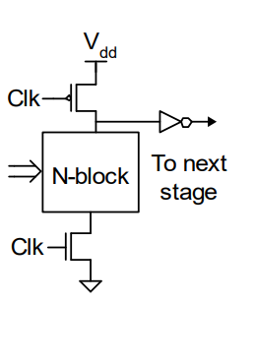

- 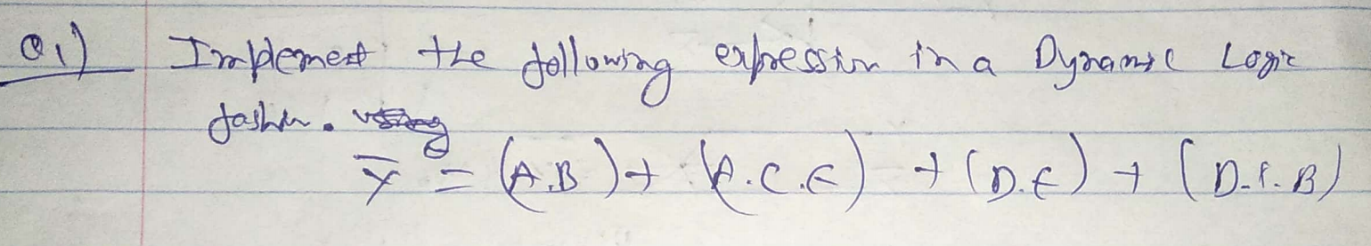
- Dynamic logic gates have faster switching speeds. Explain.

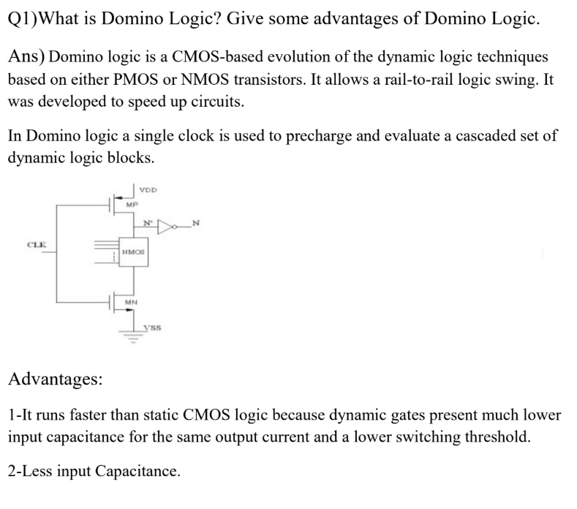

11.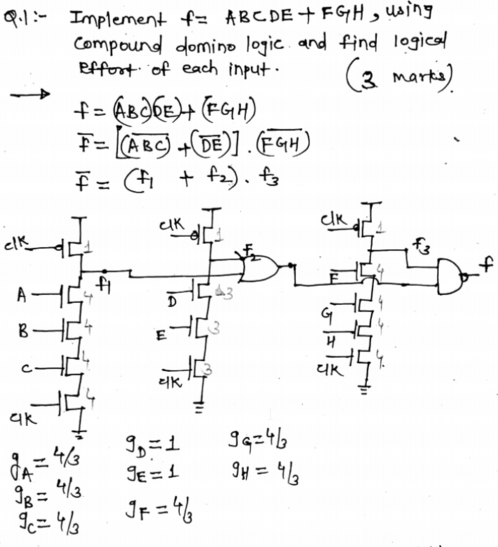

12
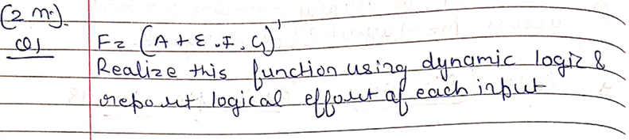

11.

12.
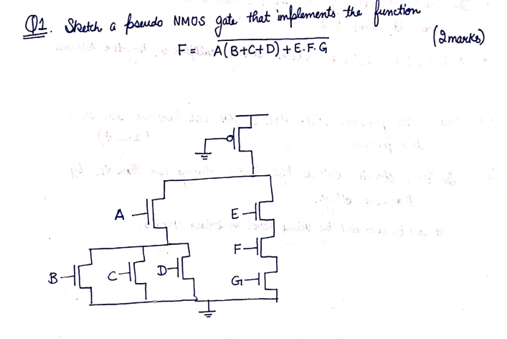
13.
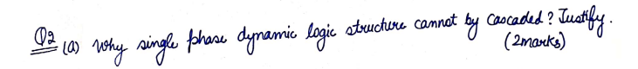
14.
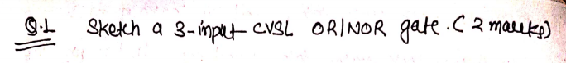
15.
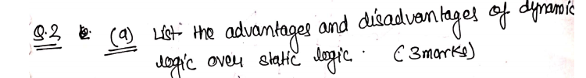
16.
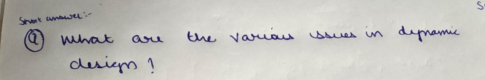

17. Dynamic logic gates have faster switching speeds. Explain.
18. Explain how domino logic is implemented and how would you reduce charge leakage,charge sharing
19. Explain the properties of Dynamic gates and the conditions on output of these gates.

20. 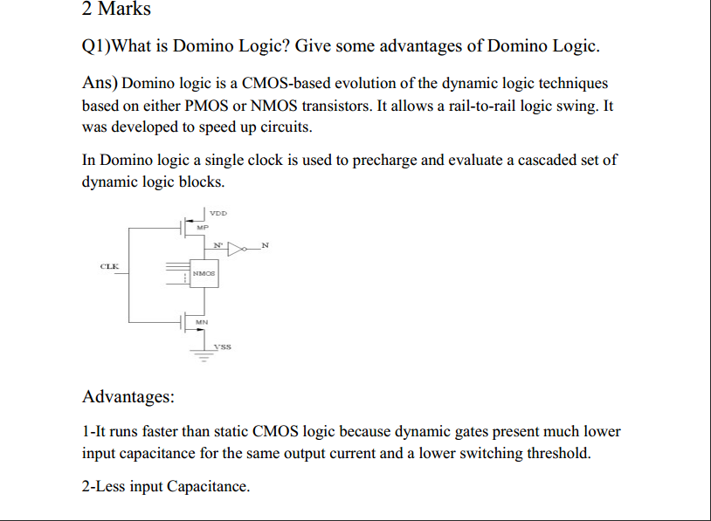
21. Mention some properties of dynamic gating?
Ans
1. The logic function is implemented by the PDN only
2. Full swing outputs (VOL = GND and VOH = VDD)
3. Non-ratioed - sizing of the devices does not affect the logic levels
4. Faster switching speeds

22. In domino Logic, output with high noise derives the static gate.
What are these parameters for high noise? Describe their effects.
Ans
1. Backgate coupling -Dynamic gates connected to multiple input
CMOS gates should drive outer input when possible.
2. charge sharing- Charge sharing can also occur when dynamic gates
drive pass transistors
3. charge leakage -Subthreshold leakage is present on the dynamic node
mostly It is worst for wider CMOS. Keepers must be sized to reduce
coupling.
4. capacitive coupling -It can occur on both input and output. It depends
on the noise margin if the gates.
5. power supply noise - VDD and GND are not constant across a large
chip. Both are subject to power supply noise caused by IR drops and
di/dt noise.
6. IR drops occur across the resistance R of the power supply grid
between the supply pins and a block drawing a current. Power supply
noise hurts performance and can degrade noise margins
7. Noise feedthrough-Noise that pushes the input of the previous stage
to near its noise margin will cause the output to be slightly degraded.
23
Write the advantages, problems, solutions and use cases for dynamic CMOS and Pass
transistor logic. (long)
Dynamic CMOS:
Advantage:
● Lesser number of transistors as compared to static CMOS circuit.
● Faster switching speed because of low input capacitance (C input ).
Problems:
● Monotonicity: if the dynamic circuit is in evaluation input it must be monotonically rising
● Charge leakage
Solutions:
● Use inverter for cascading so that the input to the other stage is also monotonically rising
● Use a keeper for charge leakage
Use cases:
● High-performance circuit

PTL:
Advantage:
● Lesser number of transistors required to implement logical functions
Problems:
● Outputs: high level is always less than V dd by the threshold voltage
Solutions:
● By implementing a Level resorting circuit
Use cases:
● Barrel shifter
● MUX’s
● SRAM’s

24.
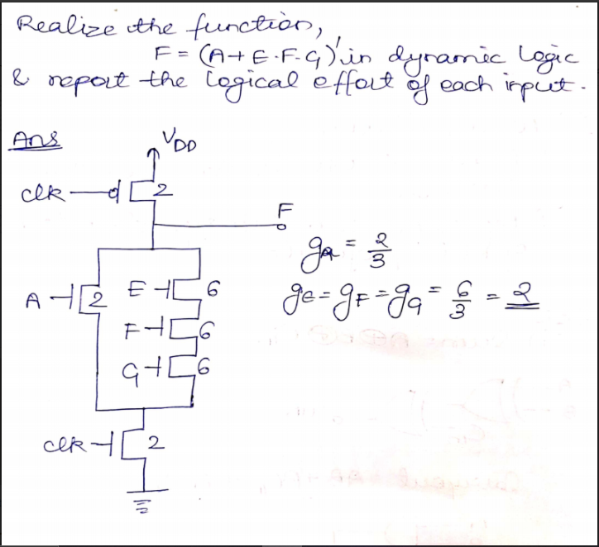

25.
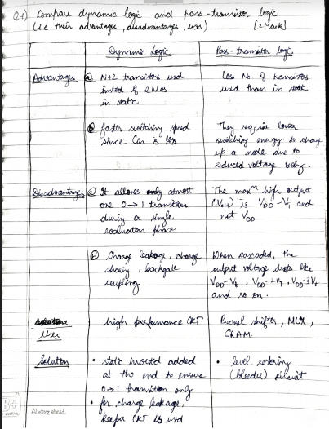

26.
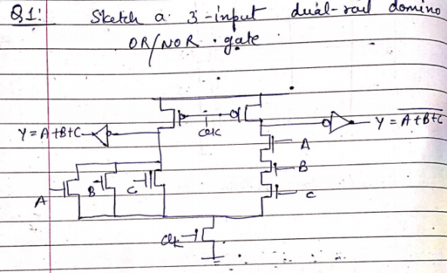

27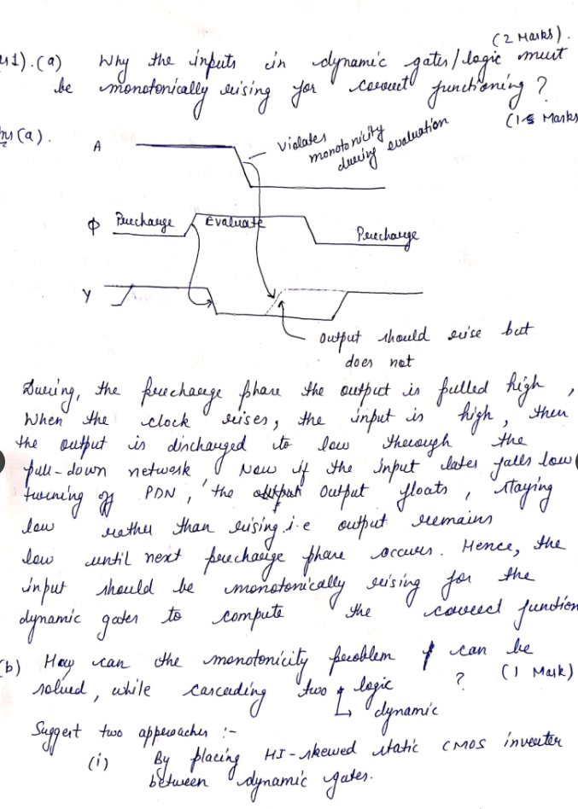
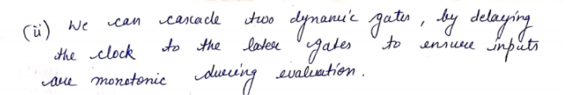

28.
What are the pitfalls in dynamic circuits? Explain 5 points
Ans) These are the following drawbacks of using dynamic circuits:
Charge leakage Subthreshold leakage on the dynamic node is presently most
important, but gate leakage will become important, too. Subthreshold leakage is
worst for wide NOR structures at high temperature (especially during burn-in).
Keepers must be sized appropriately to compensate for leakage.
Charge sharing Charge sharing can take place between the dynamic output node
and the nodes within the dynamic gate. Secondary precharge transistors should be
added when the charge sharing could be excessive. Do not drive dynamic nodes
directly into transmission gates because charge sharing can occur when the
transmission gate turns ON.
Capacitive coupling Capacitive coupling can occur on both the input and output.
The inputs of dynamic gates have the lowest noise margin, but are actively driven
by a static gate, which fights coupling noise. The dynamic outputs have more noise
tolerance, but are weakly driven. Coupling is minimized by keeping wires short
and increasing the spacing to neighbors or shielding the lines. Coupling can be
extremely bad in processes below 250 nm because the wires have such high aspect
ratios.
Back-gate coupling Dynamic gates connected to multiple-input CMOS gates
should drive the outer input when possible. This is not a factor for dynamic gates
driving inverters.
Minority carrier injection Dynamic nodes should be protected from nodes that
can inject minority carriers. These include I/O circuits and nodes that can be coupled
far outside the supply rails. Substrate/well contacts and guard rings can be
added to protect dynamic nodes from potential injectors.
Power supply noise Static gates should be located close to the dynamic gates they
drive to minimize the amount of power supply noise seen.
29.
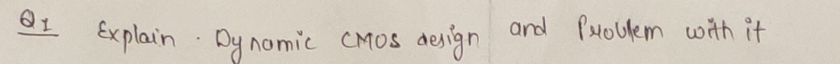

30.
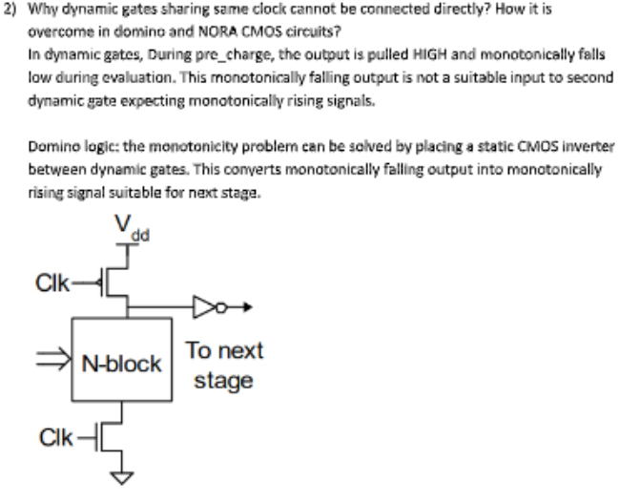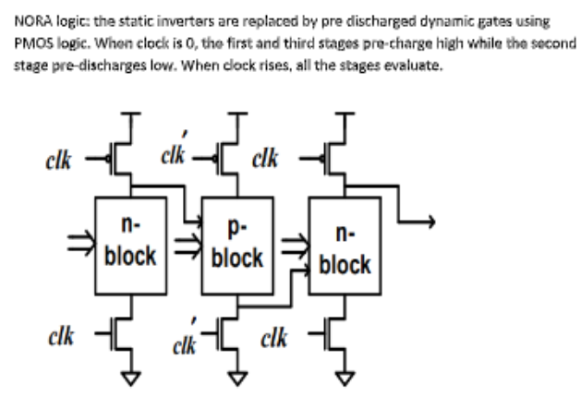

31.
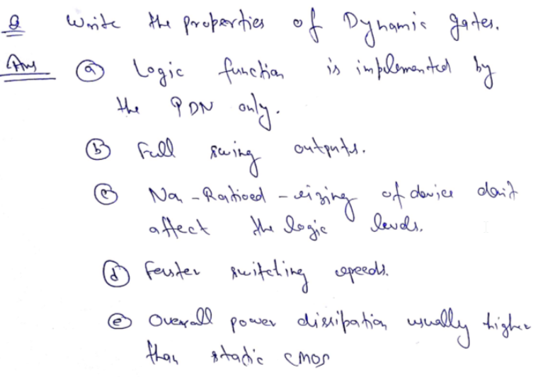

32)

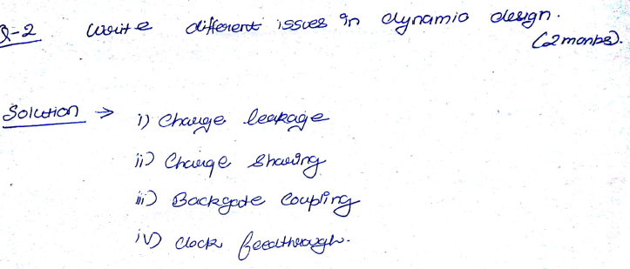
33)
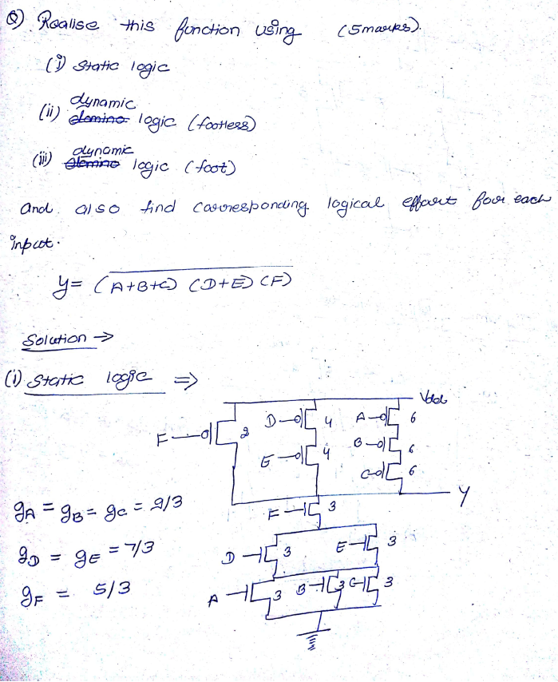
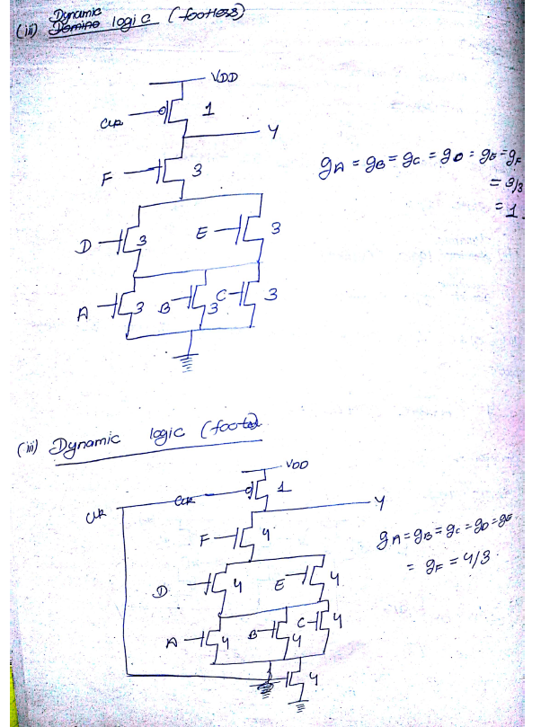

34)
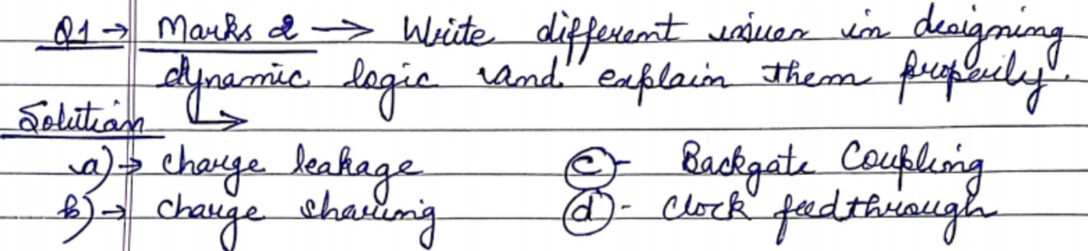
35)
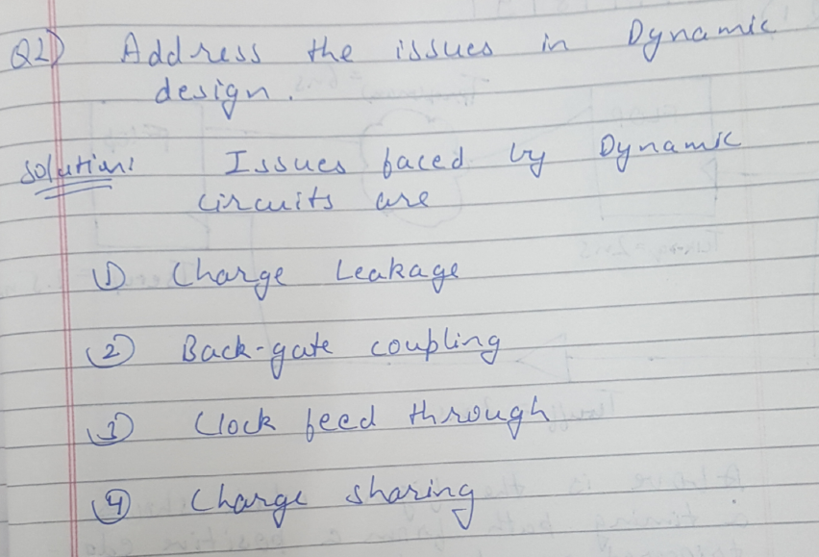

Q36.
A 3 input NAND gate is connected in series with 2 2-input NOR gates connected in series. The XOR gate presents a load of 5lambda of transistor width on the input. The output load is equivalent to 40lambda of transistor width.Find the best stage effort.

37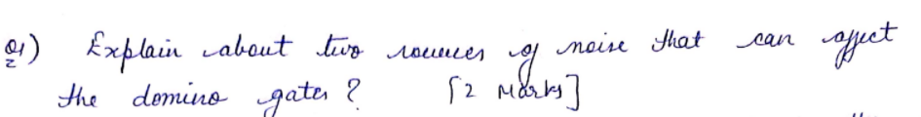
Q37.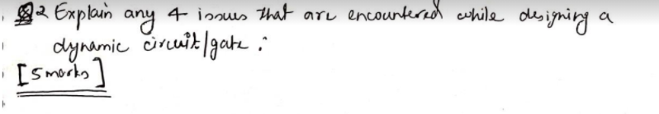
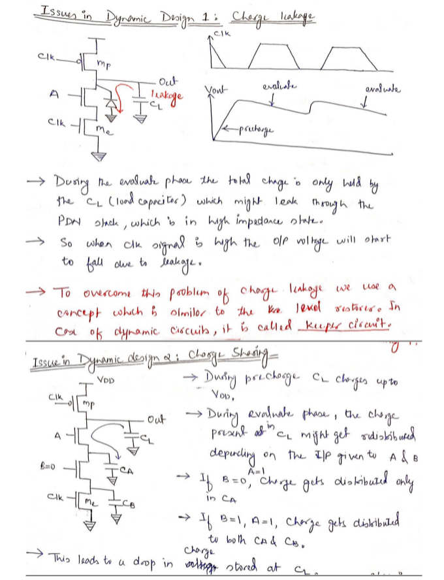
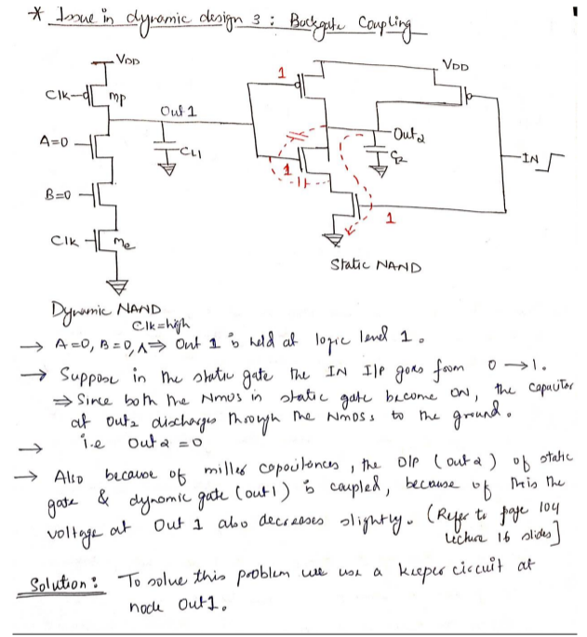
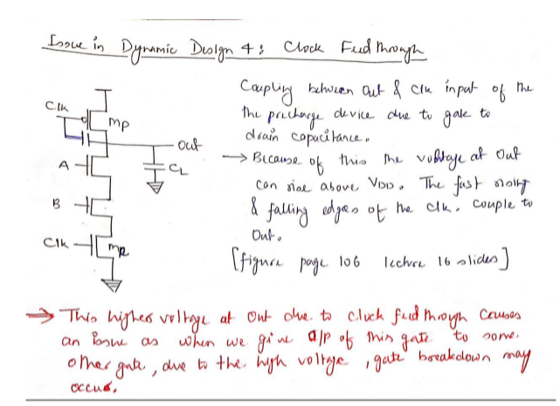

38. 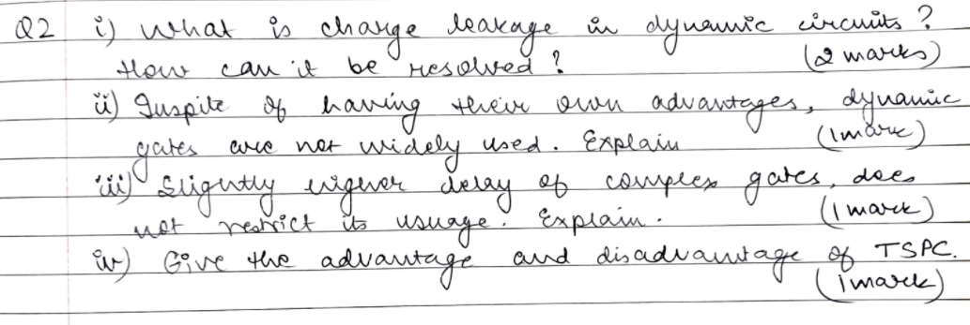
39. 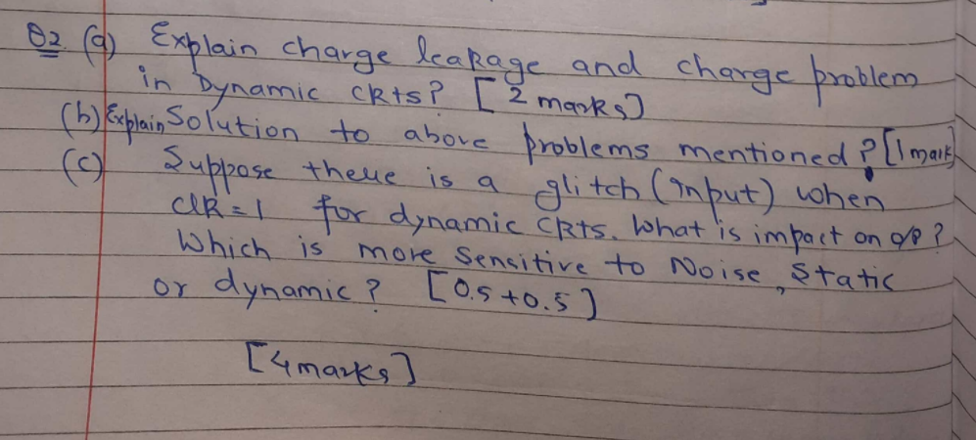

40.

41. 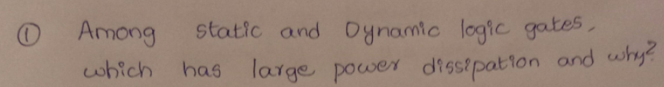

42

43

42
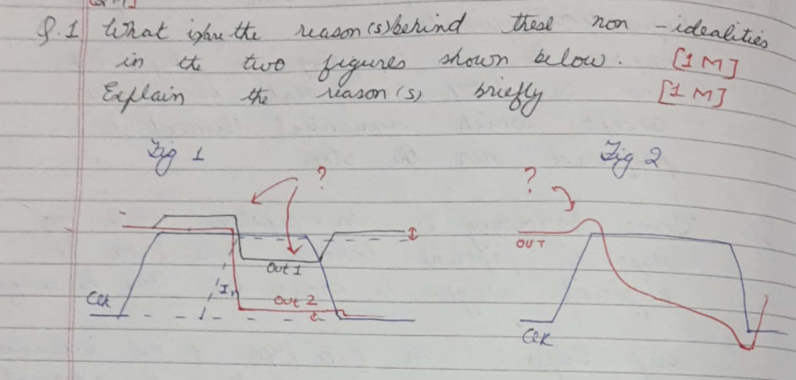
43.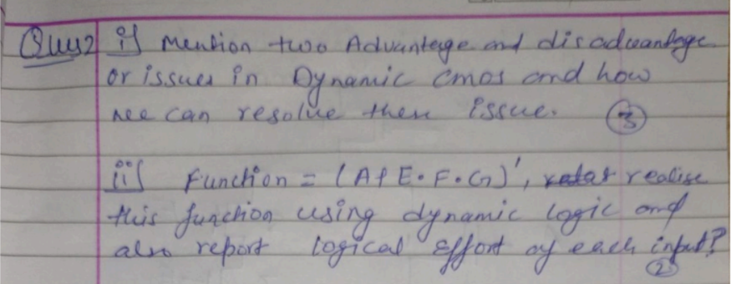
44.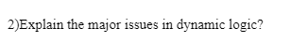
45.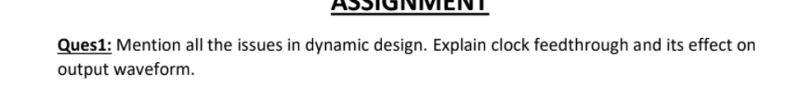

46. What are the different issues with dynamic logic? Briefly explain any
two of them. [2 Marks]
Ans. Some of the issues with dynamic logic are:-
a. Charge Leakage
b. Charge Sharing
c. Back Gate Coupling
d. Clock Coupling
a. Charge Leakage: - When pull down network gets off, Output should
remain at pre-charge state of Vdd. However this charge leaks away
gradually due to leakage currents.
b. Charge Sharing: - This is a commonly observed problem which causes
drop in the Output Voltage due to the charge sharing on capacitor.

47.

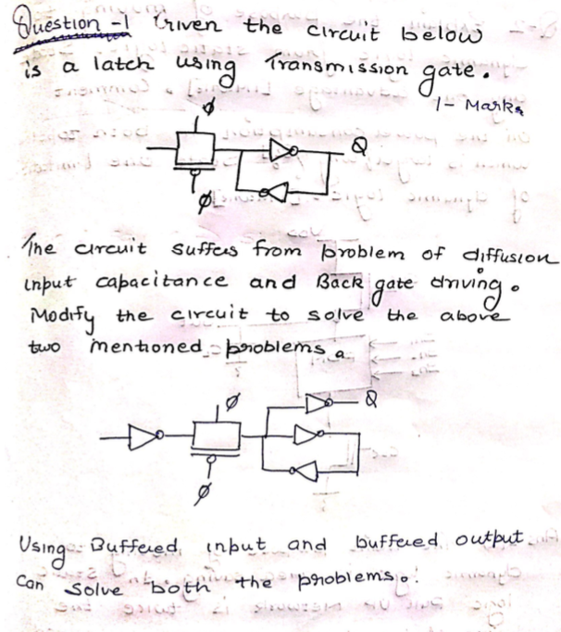

48.

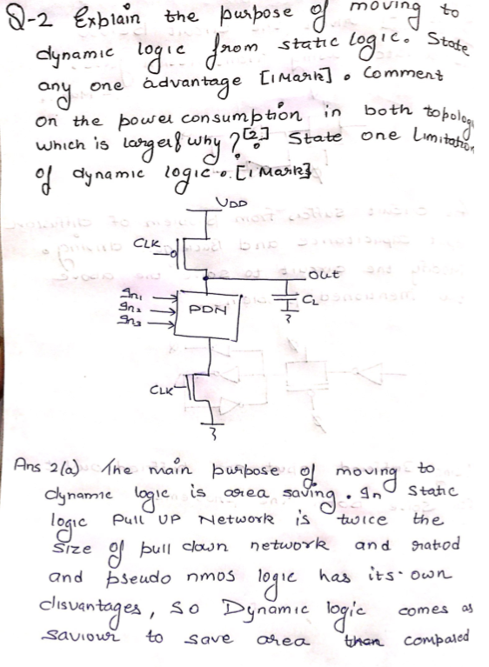

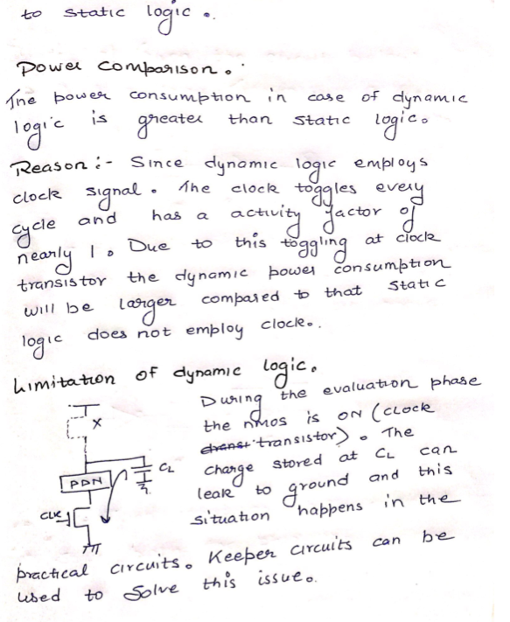

49.
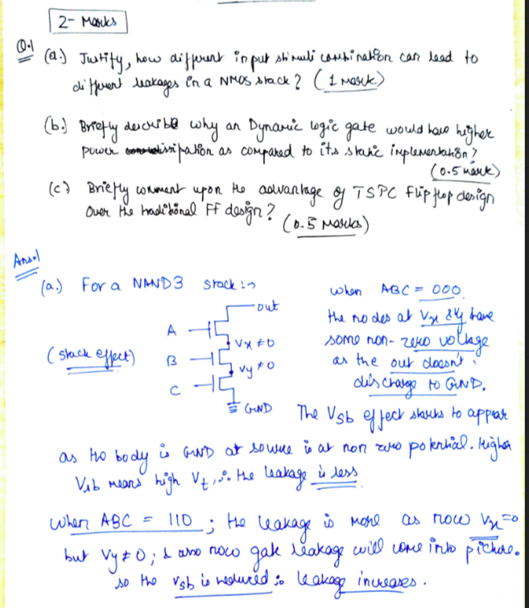
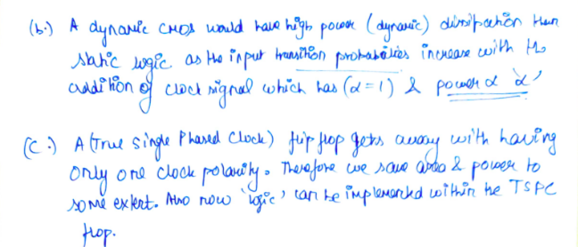

50 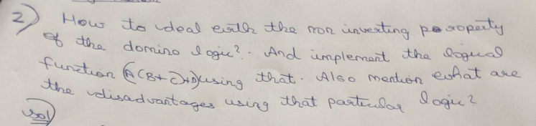

51 Explain the role of keeper PMOS in Dynamic logic (3). Also comment on how the keeper
should be sized for proper working of circuit logic

52

